Seabrook Police Department

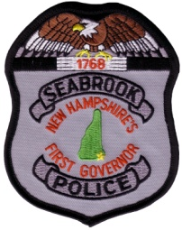
7 Liberty Lane, P.O. Box 456
Seabrook, NH 03874
Phone: (603) 474-5200
Fax: (603) 474-7242
Brett J. Walker
Chief of Police

Kevin M. Gelineau
Deputy Chief of Police

May 18, 2020
March (partial) / April / May (Partial) Report to Selectmen
March

- Seabrook voters came out with a HUGE show of support for the police department and voted yes on all the collective bargaining agreements and warrant articles related to the police department. We thank the public for recognizing our needs and being there for us.
- On Friday March 13th Sgt Justin Murphy played in the 13th Annual CHaD Battle of the Badges hockey game to benefit the Children’s Hospital at Dartmouth-Hitchcock. Due to health concerns the game was live-streamed with no spectators allowed. Although Team Police came up short, we congratulate Sgt. Murphy on being selected to Team Police and raising money for a great cause!

April

- The Chief and Deputy Chief responded to Portsmouth with the Seacoast Emergency Response Team for a team activation.

May

- The week of May 10th through 16th is National Police Week and May 15th is National Peace Officer Memorial Day. We remember all our brothers and sisters who lost their lives serving and protecting their communities especially Seabrook Police Chief Charles S. “King” Knowles who died in the line of duty on August 12, 1973.
- Chief Walker attended a virtual meeting for a work group to address opioid abuse and addiction/recovery hosted by Senator Tom Sherman.

Regular activities
- Attended numerous meetings on a variety of platforms related to the COVID-19/coronavirus updates and planning.

Drug Overdose Statistics are as follows:

2020 YTD OVERDOSES - 13
2020 YTD OVERDOSE DEATHS - 2

We continue to use our social media accounts on Facebook, Twitter, and Instagram as means of communicating with the public. This has proved to be an effective means of providing information to and interacting with the public. The Seabrookpd.com website had a Twitter feed at the bottom for people who do not utilize social media.

While we continue to limit our public interactions in order to maintain a healthy staff we look forward to resuming our regular Coffee with a Cop program as well as our other public outreach events as a means of connecting with residents. We appreciate the community thinking of us over the past few months but we are still not accepting food donations at the police department. While the State is starting to open up we are erring on the side of caution.

Despite the unprecedented challenges over the past two months, Seabrook Police staff members continue to provide the community with a high level of service to include our continued to participation in numerous drug and opioid reduction initiatives to combat the sale and distribution of illegal drugs in Seabrook and surrounding areas.

Again, we thank the voters for their support with the Union contracts as well as approving a new police radio communications system, an allocation to the police capital equipment fund, and approving the addition of two full-time police officers in March. We are still hiring for full-time police officers and anyone wishing to pursue a career in law enforcement with the Seabrook PD can apply at PoliceApp.com.

Respectfully submitted,
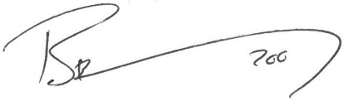

Brett Walker
Chief of Police

